Fully Voice Controlled Personal Computer

Rohit Potter
Department of Computer Science Engineering
Chandigarh University
Mohali,India
rohitpotter12@gmail.com
Suraj Sachan
Department of Computer Science Engineering
Chandigarh University
Mohali,India
suraj.sachan@gmail.com

Karan Thakur
Department of Computer Science Engineering
Chandigarh University
Mohali,India
karanthakur577@gmail.com

Abstract—In this paper we present the voice controlled PC. The system basically takes a human voice as a input and through libraries it processes that voice and convert that into text to perform that task in PC and to communicate with us.
Keywords—Speech Recognition, personal computer

Introduction
Voice recognition PC is great challenge since there is a lot of different ways to say a particular thing and lot of different voices. This project will recognize the sentences which are spoken by the user and and perform that particular task which are spoken by the user. This project uses preexisting python libraries to perform different task like recognizing sentences, speaking sentences, download song, play song, search result on browser etc. This project will be like fully interactive personal computer.
The rest part of the paper includes the following: Section 2 discusses about the related work. Section 3 presents brief discussion about the proposed work. Section 4 gives details about the methodology which includes the information about the data, methods followed etc. Section 5 explains summary and future scope of the project.

RELATED WORK
Voice-enabled user interfaces have become a popular means of interaction with various kinds of applications and services. In addition to more traditional interaction paradigms such as keyword search, voice interaction can be a convenient means of communication for many groups of users [1]. Intelligent Systems, pay close attention to recent technological developments related to the emergence of Intelligent Assistants to allow the development of Smart Voice Assistants for efficient recovery and access to geographic information [2]. Voice User Interfaces (VUIs) are becoming ubiquitously available, being embedded both into everyday mobility via smartphones, and into the life of the home via 'assistant' devices [3]. When voice assistants are perceived as humanlike agent, the likelihood of forming a pseudo-human relationship with voice assistants is expected to increase [4]. Past work on speech technology has lacked a strong involvement of Human Computer Interaction (HCI) research [5]. It was not until recently that work has been done around discovering and understanding the practical actions and reasoning of people using VUIs in social settings such as the home [5].

MATERIAL AND METHODS
In the previous papers only the voice is recognised, converted into text and PC can speak the text written. We are converting the voice into the text through pre existing python libraries and use that as a input to perform the task. Here we are initially take voice as a input and convert that voice into text thorugh pre existing python libraries. Then that text is used to identify what task is to perform using if-elif-else and then the task is perform using system commands and output is converted into text to speech using pre-existing python library. This is how we control PC with voice.

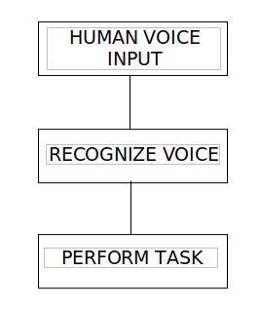

Figure 1: Proposed flowchart
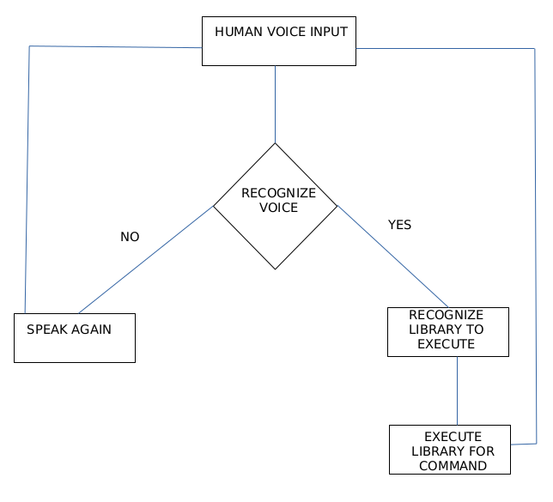
Figure 2: Detailed Flowchart

EXPERIMENTAL INVESTIGATION
This section discusses about the experimental setup.

Experimental setting

Python is used to perform various task in personal computer. Python’s speech_recognition library is used to convert voice command into text. Python’s googlesearch library is used to show search result of google on command line. Python’s gtts library is used to convert text into speech. Python’s selenium library is used to open bot web browser and search various input automatically. The aim is to listening the following input from the user and perform that task in personal computer.

RESULT AND DISCUSSION
This section discusses the various commands input to test the voice controlled personal computer. The results are much in detail and also screenshot of the ouput is pasted.
After experimentation and testing of different commands , the results of various command input are in Figure 3,4,5.
Figure 3 shows the listening of the personal computer for the command and if the personal computer is not able to recognise the voice then it will again to speak again.
Figure 4 shows the listening of song downloading command and downloading of song. After listening of downloading command personal computer ask for which song to download and download that song.
Figure 5 shows the listening of play song command and playing song. After listening of play song command, personal computer ask for which song want to play and play that song.
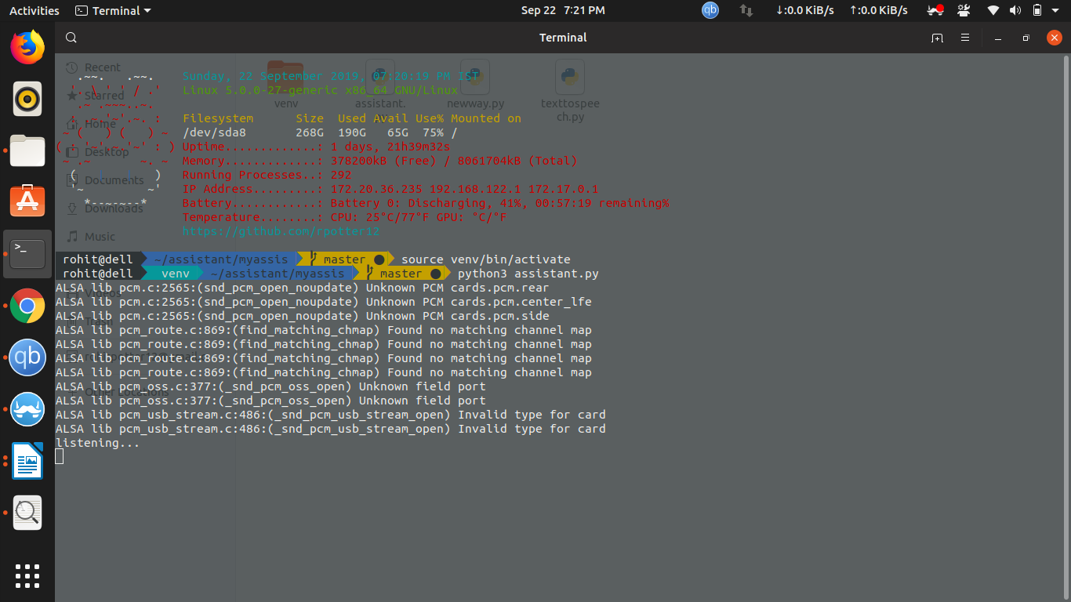
Figure 3: Command Output

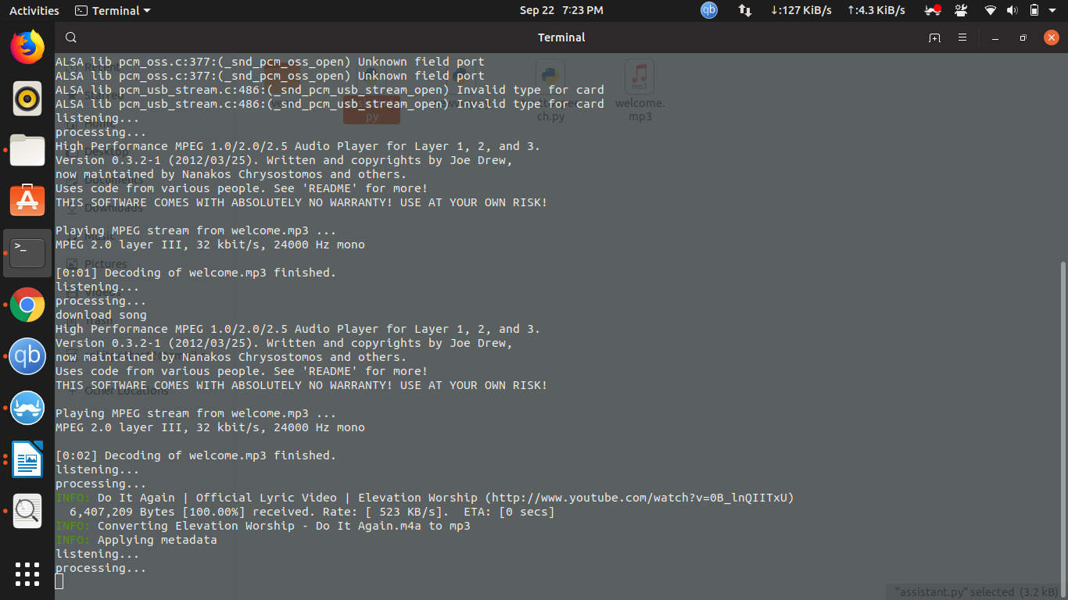
Figure 4: Command Output

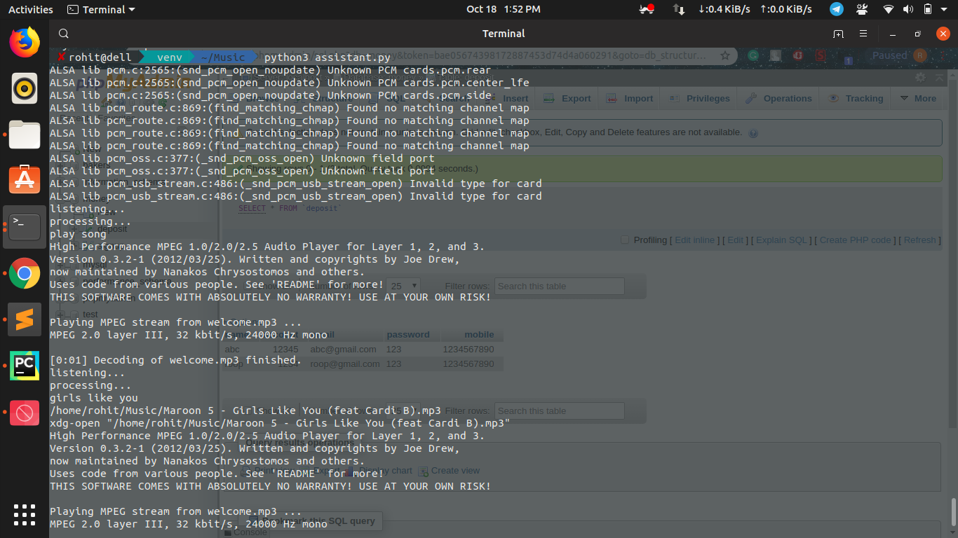
Figure 5: Command Output

VI. CONCLUSION AND FUTURE SCOPE
A voice-user interface (VUI) makes spoken human interaction with computers possible, using speech recognition to understand spoken commands and answer questions, and typically text to speech to play a reply. A voice command device (VCD) is a device controlled with a voice user interface. In this research, voice and pre existing python libraries used to perform different task in the operating system.
An efficient script is written using pre-existing python libraries which will help user to control their whole PC with voice only.
For future work, Natural language processing will be used for better output and to interact with the personal computer very easily. Further more task will be added which can be performed by the script and can be performed in any operating system.

References

- P. Haase, A. Nikolov, J. Trame, A. Kozlov and D.M. Herzig Alexa, Ask Wikidata! Voice interaction with knowledge graphs using Amazon Alexa, in: Proceedings of the ISWC 2017 Posters & Demonstrations and Industry Tracks Co-located with 16th International Semantic Web Conference (ISWC 2017), Vienna, Austria, 2017
- Miguel Ángel Bernabé, Jacinto Estima, María Ester González, Carlos Granell, Carlos López-Vázquez and Miguel R. Luaces, IDEAIS: Smart Voice Assistants to Improve Interaction with SDIs, 2019
- Claire Whang and Hyunjoo Im, Voice Shopping: User-Voice Assistant Parasocial Relationship Perspective, 2018
- Martin Porcheron, Stuart Reeves and Sarah Sharples, Voice interrface in everyday life, 2018
- Gisela Reyes-Cruz and Joel Fischer and Stuart Reeves, An ethnographic study of visual impairments for voice user interface design, 2019

